**Introduction:**

A huge amount of clinical reports is generated through a person life considering the disease they are diagnosed with; time they are diagnosed with the diseases and treatment they are undergone. This data is very sensible to monitor as the hold sensitive information in the and there is a huge risk of compromising privacy of patients if they are not monitored properly. Owning this kind of information with complete access that allows the person who owns it to create, modify and sharing of medical data would add value to data one has.

Blockchain provides the encryption required for the data owned by the patients with secured storage, sharing and monitoring. Use of Blockchain in handling patient records opens a whole new dimension in data sharing for research and development and making economy form the data patient owned. Blockchain and “zero knowledge” along with distributed ledger makes an efficient data monitoring system that provide shared access of patients data to the person who owns it who is a patient, doctor and the person with whom it is shared which may be a research organization or a paramedical company. This provide secured and shared access of data and establish trust about the authenticity of data shared.

MyCONTEXT cancer records intends to leverage the power of Decentralised Ledger Technology (DLT) to provide extended accessibility, monitoring and secure access to Patients cancer records across all medical care centres. This will provide easy access, modification and as well as secure access to Patients, hospital and research organisations to the data by reducing time and effort taken to make it available for collaborations.

**Technology**

**Blockchain**

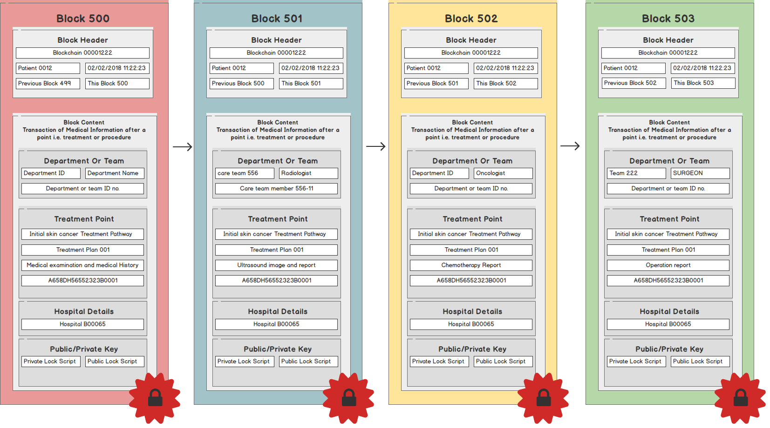

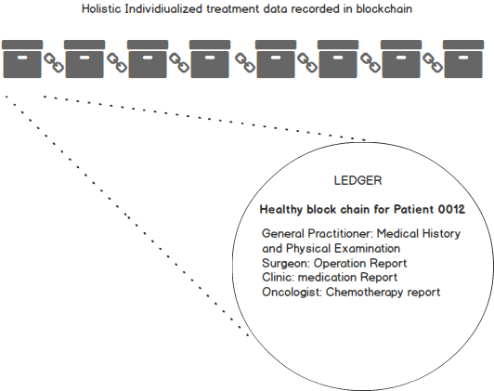

**Architecture**

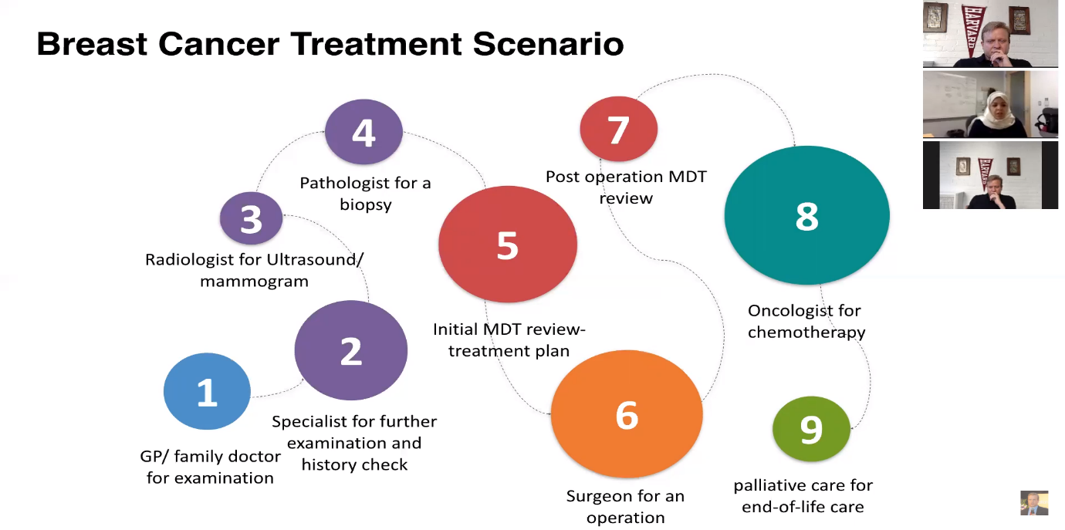

**REST API Services**

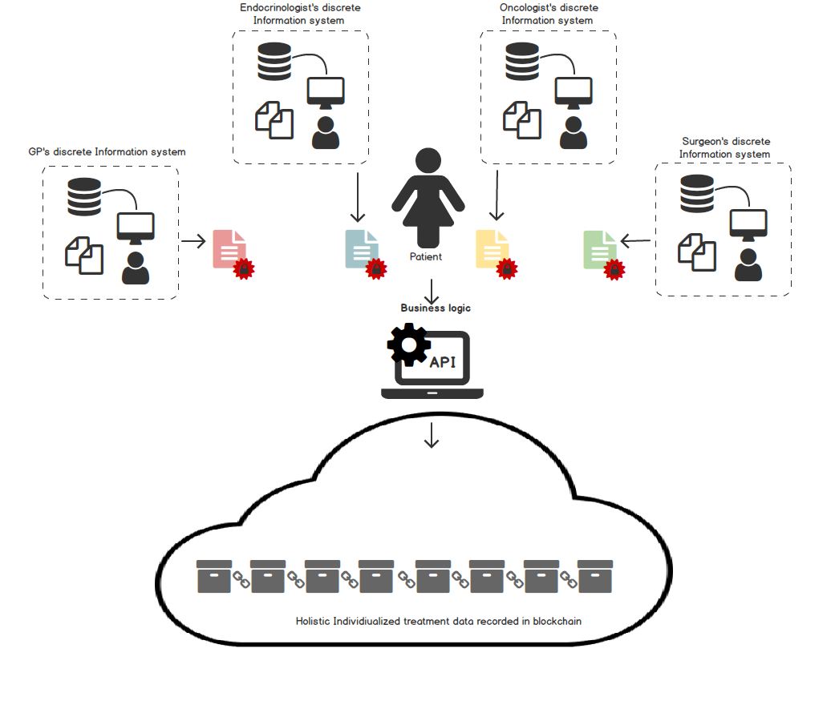

**UI**

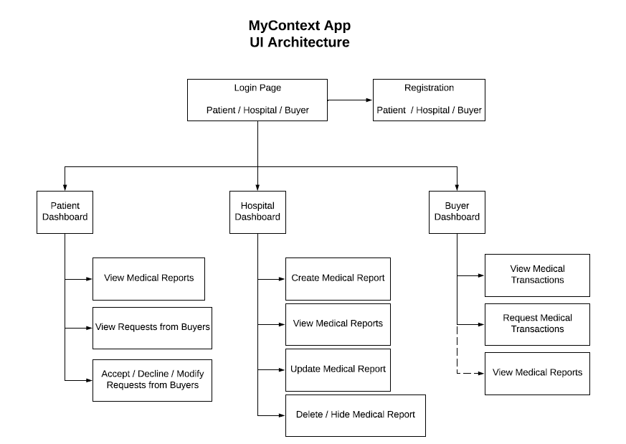

Navigation Model

**API**

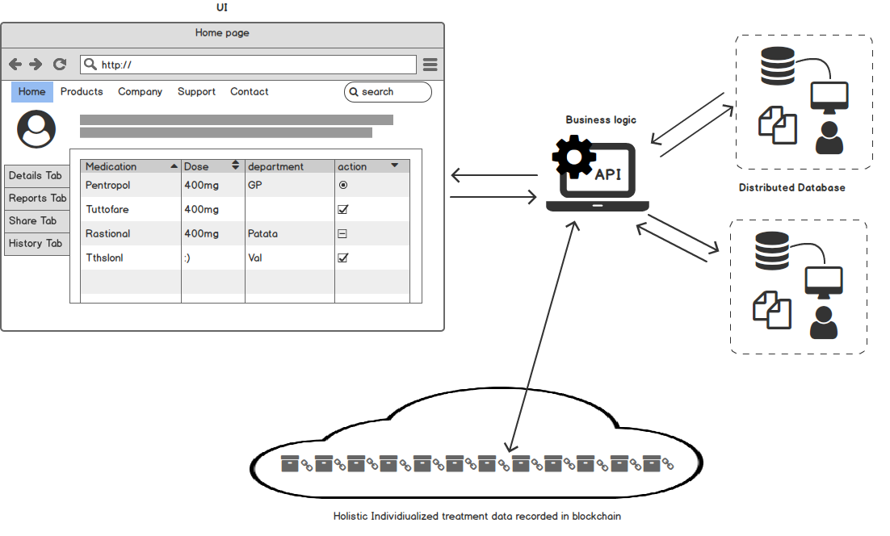

**Database**

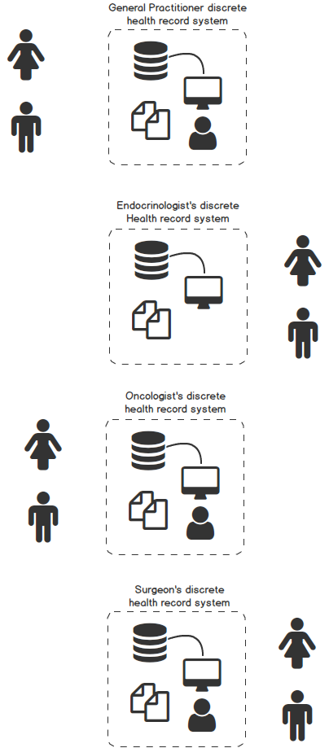

**UI and API interfacing with Blockchain**



**Scope**

Data has been generated at a rapid rate in different domains like Weather, Health, Intelligence, Ecommerce and so on. In the field like Health that contain sensitive information can affect a person, if it fell into wrong hands. Maintaining these records are of great task for the hospitals as it need a strong IT team to make sure it doesn’t fell into wrong hands. On the top of it sharing these records through safe and secure path with authenticity won’t be easy. But this data can be used by the research organization and paramedical groups for in-depth analysis of drug usage and how it is working on its hosts to cure a certain disease it is intended to make. All these challenges can be address with the help of Blockchain encryption. A Distributed Ledger Technology (DLT) can be considered to provide safe and secure access to the patient records fir research organizations and paramedical companies as well as allowing the patient to have control over their records.

It is too hard for an organization to own cancer patient records and takes huge organizational resources which may lead to compromising of data. It needs real time monitoring to maintain records up-to-date. Blockchain technology is used to encrypt our data which is maintained in Decentralized. DLT have a wide range of commercial advantages starting from reduction in organizational coast, providing transparency and authenticity to records, making transactions and payments fast and automatic by reducing different layers of approval and therefore reducing the approval time. By decentralizing the system records can be access anywhere by making them available over a network of systems and can be used for many purposes.

To make the working model of MYCONTEXT Cancer Records over Blockchain need a simple data set that consists the records of cancer patients, adatatool for specific data collection for patient care details across many unlinked records. The heart of Blockchain lies in the server that add the transactions to the blockchain that contain access control logic and module that gives the permission for access the records for individuals, CRUD of individual health records implements on a blockchain.

**Conclusion**

Cancer patient records can be access over a network of systems by Blockchain Technology along with Distributed Ledger Technology (DLT). This make the records more safe and secure with fast access for its clients. This also provide the authenticity and transparency required making the Blockchain technology to be the most preferable one over already existing technology. As it doesn’t require much operational cost it is more affordable and preferable. But like every other technology, Blockchain Technology also has its own limitations. As it is the new technology to the world there are lot of aspects that must be explored in Blockchain Technology and making it familiar to the world. And also work has to be done in the aspect of areas where Blockchain can be implemented instead of current using technology making data more safe and secure. Work can be done in exploring different dimensions of Blockchain technology and the areas in which it can be implemented.

**References**

**Mock Up Pages** 